Layer-2 Settlement
# Source: AI Source: Provided by: [Data Path: Persons Table -> ID Column: 1, Name_En Column: Motasem Essam] -> From: [ChatGPT] on [1/21/2026]
Layer-2 settlement refers to transactions processed off the main blockchain (Layer 1) using a secondary network (Layer 2) to improve speed, scalability, and cost efficiency. The final state or summary of transactions is later settled back on the main blockchain for security and finality.

🧠 Simple Definition
# Source: AI Source: Provided by: [Data Path: Persons Table -> ID Column: 1, Name_En Column: Motasem Essam] -> From: [ChatGPT] on [1/21/2026]
Layer-2 settlement means processing many transactions off-chain, but recording a compressed or verified summary on the main chain (Layer 1), combining speed with blockchain security.

🔗 How It Works
# Source: AI Source: Provided by: [Data Path: Persons Table -> ID Column: 1, Name_En Column: Motasem Essam] -> From: [ChatGPT] on [1/21/2026]
- Users perform transactions on Layer 2 (e.g., sending tokens or trading).
- These are bundled, validated, and recorded on the Layer-2 system.
- Periodically, a proof of those transactions is posted to Layer 1 (e.g., Ethereum).
- This anchors the off-chain activity to the blockchain, ensuring finality.

🌐 Popular Layer-2 Networks
# Source: AI Source: Provided by: [Data Path: Persons Table -> ID Column: 1, Name_En Column: Motasem Essam] -> From: [ChatGPT] on [1/21/2026]
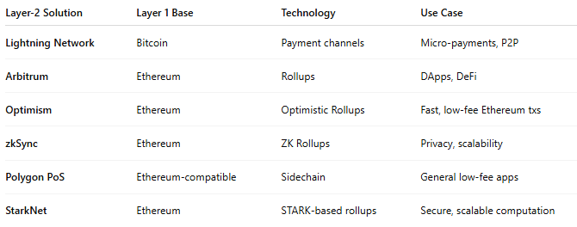

Layer-2 Solution | Layer 1 Base | Technology | Use Case
Lightning Network | Bitcoin | Payment channels | Micro-payments, P2P
Arbitrum | Ethereum | Rollups | DApps, DeFi
Optimism | Ethereum | Optimistic Rollups | Fast, low-fee Ethereum txs
zkSync | Ethereum | ZK Rollups | Privacy, scalability
Polygon PoS | Ethereum-compatible | Sidechain | General low-fee apps
StarkNet | Ethereum | STARK-based rollups | Secure, scalable computation

🚀 Why Use Layer-2 for Settlement?
# Source: AI Source: Provided by: [Data Path: Persons Table -> ID Column: 1, Name_En Column: Motasem Essam] -> From: [ChatGPT] on [1/21/2026]
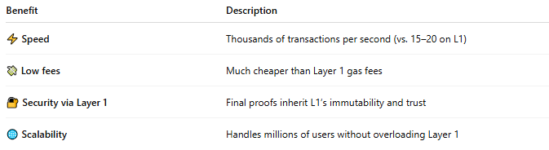

Benefit | Description
⚡ Speed | Thousands of transactions per second (vs. 15–20 on L1)
💸 Low fees | Much cheaper than Layer 1 gas fees
🔐 Security via Layer 1 | Final proofs inherit L1’s immutability and trust
🌐 Scalability | Handles millions of users without overloading Layer 1

🛠️ How Final Settlement Occurs
# Source: AI Source: Provided by: [Data Path: Persons Table -> ID Column: 1, Name_En Column: Motasem Essam] -> From: [ChatGPT] on [1/21/2026]
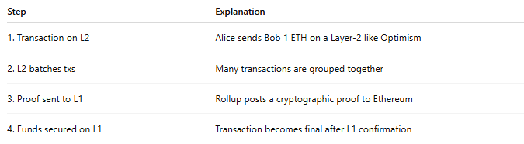

Step | Explanation
1. Transaction on L2 | Alice sends Bob 1 ETH on a Layer-2 like Optimism
2. L2 batches txs | Many transactions are grouped together
3. Proof sent to L1 | Rollup posts a cryptographic proof to Ethereum
4. Funds secured on L1 | Transaction becomes final after L1 confirmation
⏳ Some L2s (like Optimistic Rollups) introduce a delay window (e.g., 7 days) for dispute resolution before finalizing the settlement on L1.

🧾 Use Cases for Layer-2 Settlement
# Source: AI Source: Provided by: [Data Path: Persons Table -> ID Column: 1, Name_En Column: Motasem Essam] -> From: [ChatGPT] on [1/21/2026]
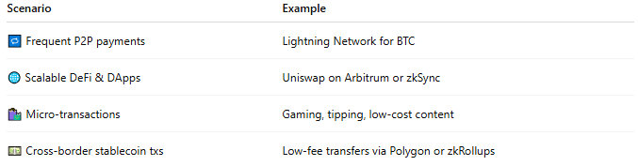

Scenario | Example
🔁 Frequent P2P payments | Lightning Network for BTC
🌐 Scalable DeFi & DApps | Uniswap on Arbitrum or zkSync
🛍️ Micro-transactions | Gaming, tipping, low-cost content
💵 Cross-border stablecoin txs | Low-fee transfers via Polygon or zkRollups

🔐 Security Considerations
# Source: AI Source: Provided by: [Data Path: Persons Table -> ID Column: 1, Name_En Column: Motasem Essam] -> From: [ChatGPT] on [1/21/2026]
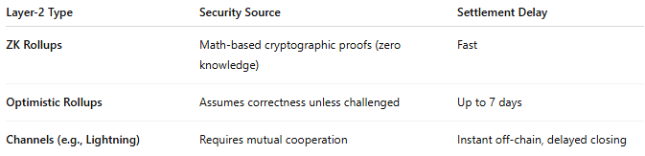

Layer-2 Type | Security Source | Settlement Delay
ZK Rollups | Math-based cryptographic proofs (zero knowledge) | Fast
Optimistic Rollups | Assumes correctness unless challenged | Up to 7 days
Channels (e.g., Lightning) | Requires mutual cooperation | Instant off-chain, delayed closing

⚖️ Pros and Cons
# Source: AI Source: Provided by: [Data Path: Persons Table -> ID Column: 1, Name_En Column: Motasem Essam] -> From: [ChatGPT] on [1/21/2026]


✅ Pros | ❌ Cons
High throughput, low fees | Additional complexity for developers
Leverages Layer-1 security | May require waiting period for finality (rollups)
Ideal for micropayments and mass usage | UX still maturing (wallets, bridges, etc.)

🧠 Summary
# Source: AI Source: Provided by: [Data Path: Persons Table -> ID Column: 1, Name_En Column: Motasem Essam] -> From: [ChatGPT] on [1/21/2026]
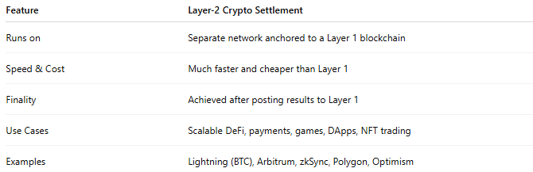

Feature | Layer-2 Crypto Settlement
Runs on | Separate network anchored to a Layer 1 blockchain
Speed & Cost | Much faster and cheaper than Layer 1
Finality | Achieved after posting results to Layer 1
Use Cases | Scalable DeFi, payments, games, DApps, NFT trading
Examples | Lightning (BTC), Arbitrum, zkSync, Polygon, Optimism

